**Appendix 'T'**

(Para 18 of CGAE (PBR) Fact Sheet refers)

**COAST GUARD KINDERGARTEN**

1. Coast Guard Kindergarten was established on 15 Jul 1996. The school started with a meagre strength of 07 students and one teacher in a wooden shed in the name of Udyan KG School under the guidance of Deputy Inspector General D Banerjee, PTM, COMCG (A & N) and Mrs. Renuka Raj as the Headmistress. Presently, 149 students are on the roll with 08 teaching and 12 non-teaching staff members. Coast Guard Education Society, Port Blair was registered on 24 Jan 18 and subsequently school was registered with Andaman & Nicobar Education Department on 27 Jun 18 as Coast Guard kindergarten. The school provides 25% seats for admission to children belonging to weaker section.

2. **School Activities**. The school celebrates and observes all national and regional festivals to educate children about the Indian culture. In addition, activities incorporating moral and social values such as Tree Plantation day, Grandparents Day, Health Camp, Colours Week, Health & Nutrition Day are also celebrated. Educational Trips are conducted on a regular basis to enhance the inquisitiveness of young minds. Despite striking of COVID pandemic, school has continued to conduct all events through virtual mode involving pupil’s participation in coordination with parents from home following COVID- 19 protocols and guidelines.

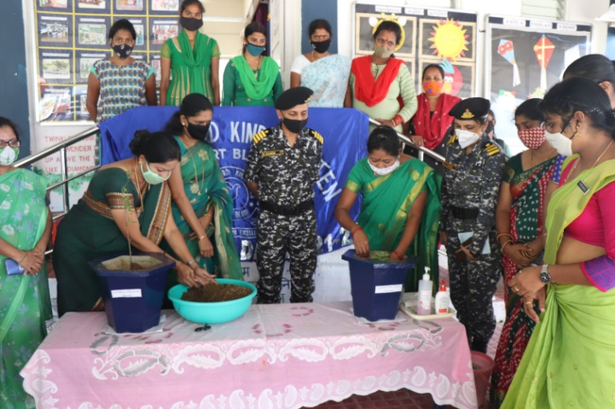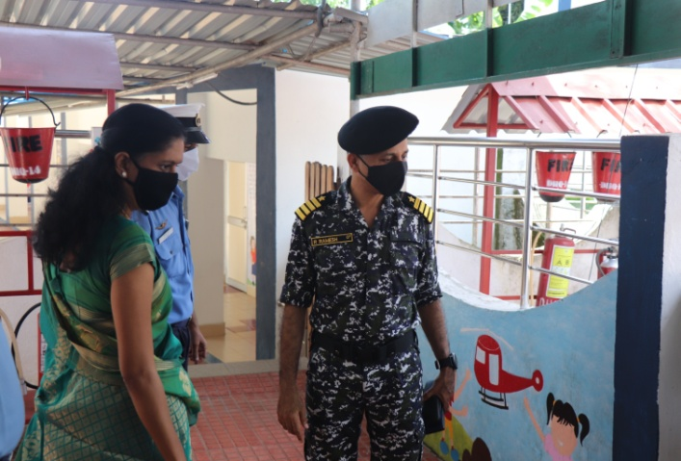

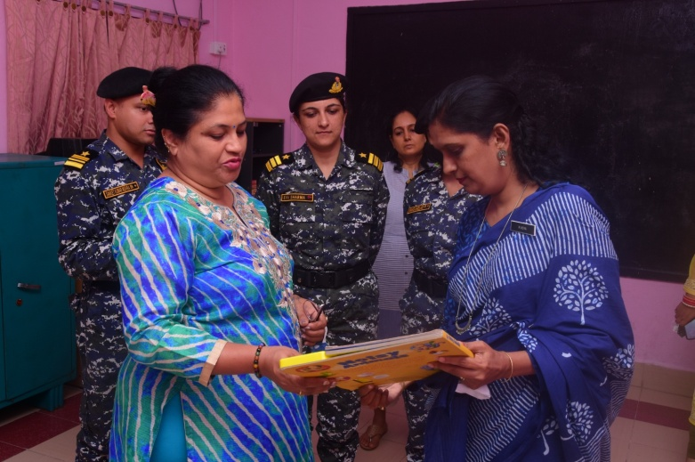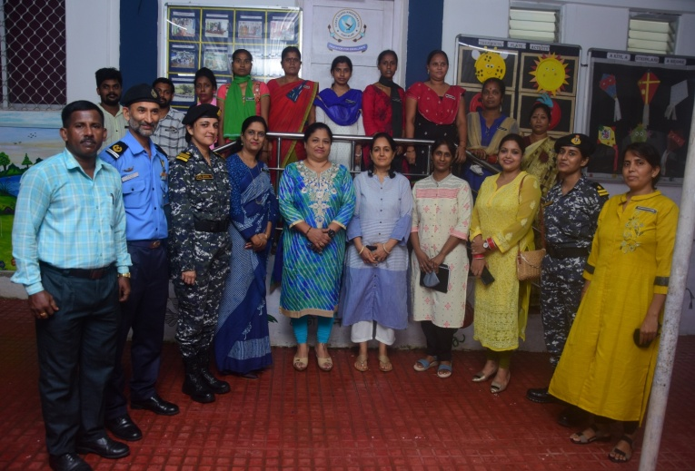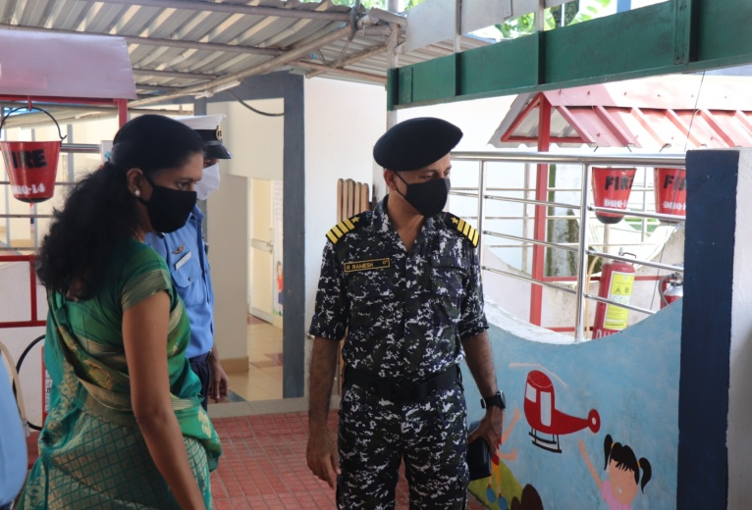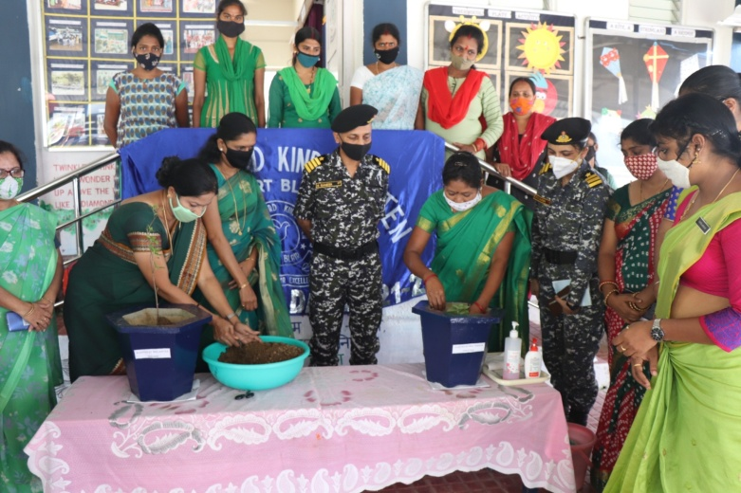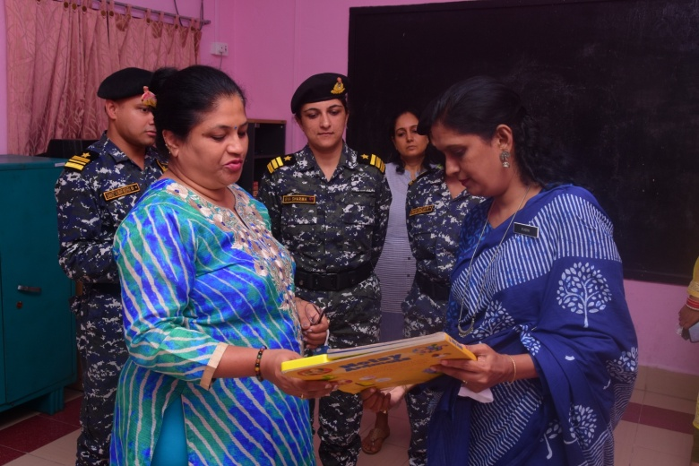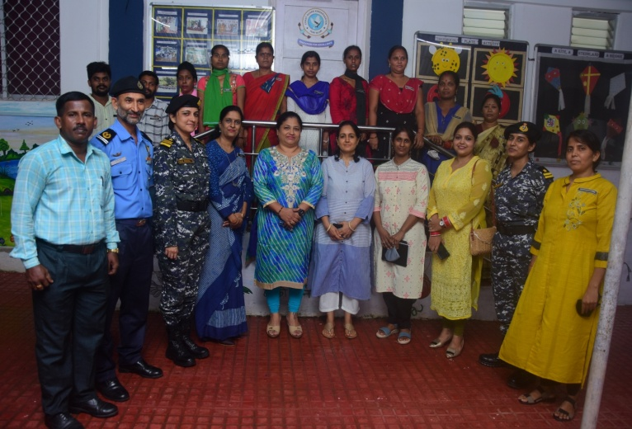

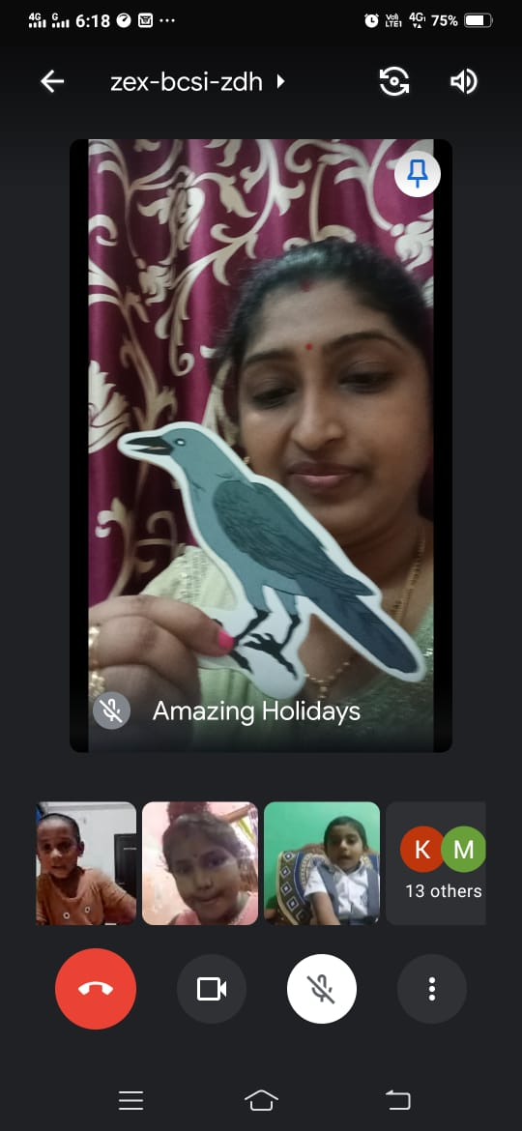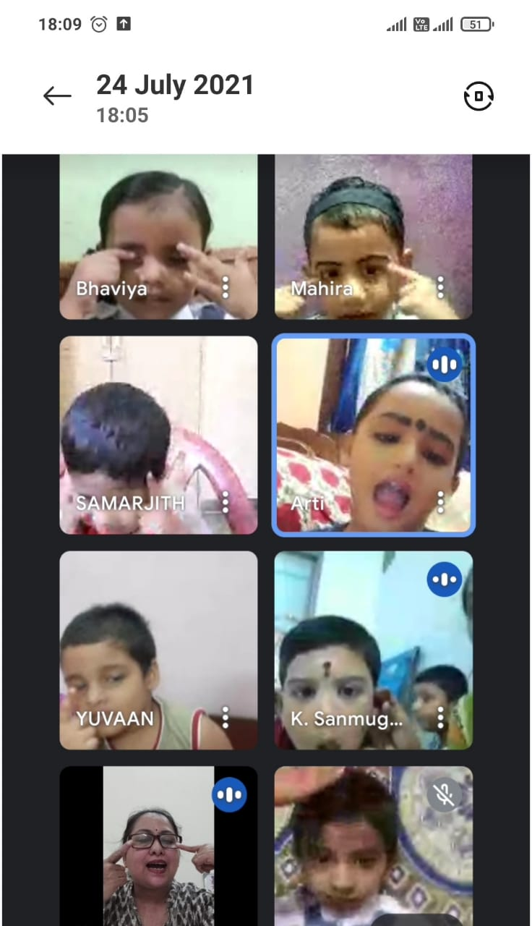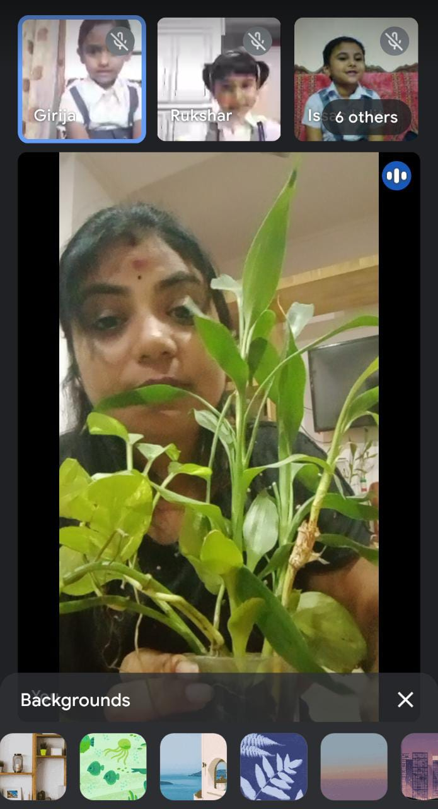

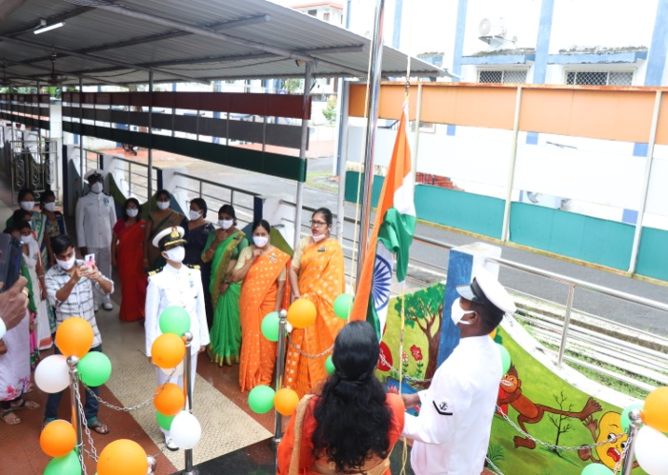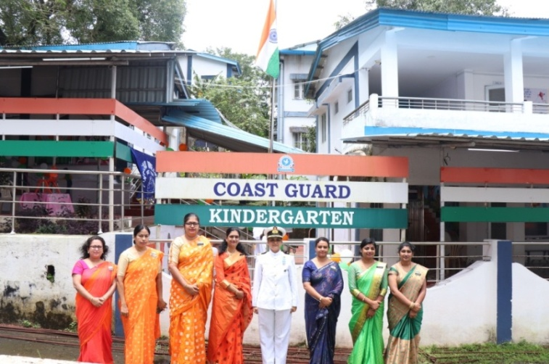

3. Online classes/ activities are being conducted for the kids using virtual platforms like whatsapp/ other applications by creating groups of respective classes led by class teachers in line with COVID- 19 protocols as implemented by government.

4. **Virtual Celebrations**. The school has initiated live digital celebrations. Following activities/ celebrations have been carried out virtually using Google Meet by sharing a common link by teachers from school and kids/ parents joining from home:-

(a) Independence Day

(b) Krishna Janmashtami

(c) Ganesha Charutathi

(d) Diwali

5. **Admission of Special Child**. Admission of a special child named Master Anurag Kumar Amar, S/o Mr Santosh Kumar Amar has been carried out during Oct 21 post duly scrutinizing the case, in class Nursery as a regular student subject to reviewal after restoring of regular classes. The kid is a special child with Down Syndrome. He was interviewed/ interacted with by Headmistress and has shown nil symptoms of emotional outburst or movement disabilities. The child has controlled saliva movement as well as walking/ locomotory skills. He is able to recite alphabets, numbers, rhymes as well as identify colours.

6. **CGKG Staff & Miscellaneous Details**

* 1. Headmistress : 01
  2. No. of Teaching Staff : 07
  3. No. of Non teaching Staff : 12

1. Office-Assistant - 02
2. Peon - 01
3. Sahayikas - 08
4. Security - 01
   1. No. of Classes : 07

Play Group - 01 Division

Nursery - 02 Divisions

LKG - 02 Divisions

UKG - 02 Divisions

* 1. School Timings : 0830 – 1230 hrs (Monday to Friday)

*Timings amended to 0900- 1200 hrs for conduct of online classes (01 Hour duration each)

* 1. Staff Timings : 0800 – 1300 hrs (for Teachers)

0730 – 1530 hrs (for non teaching staff)

7. **Achievements**

1. Audit of school fund account by CA for FY 20-21 is completed.
2. Construction work of retaining wall behind school office is completed.
3. Walls of school are being painted by Janki Rao, Choukidar with poems and cartoons.
4. Recruitment for the post of Trained Teacher has been carried on 02 Aug 21.
5. Work for development of children play area (Hard standing/ sand cushioning) is completed.
6. Provisioning of drainage system has been made in the children play area.
7. Procurement of Hand Sanitizing Machine (Touchless).

8. **Future Upgradation Plans**

1. Introduction of school website.
2. Construction of additional class room building (G+2) for school.
3. Up-gradation of CGKG to Ist and subsequently to IInd standard post construction of G+2 building.